¡Bienvenidos a Español 3 con Profesora Rolón!
Let’s start with some FAQs
What can I expect from Spanish this year?
Most students are pretty nervous to start Spanish 3. Hopefully you’re more excited than nervous, but just in case, here is a quick overview. In Spanish 3 we continue to learn new and more complex vocabulary, and we review all the grammar concepts you did in Spanish 1 and 2 in order to aim at perfecting those concepts. This does not mean I expect perfection – it means that I expect a concerted effort to improve your Spanish. We will also do some reading, write short essays, play games, talk (a lot), collaborate on projects, act, listen to music and explore some cultural aspects of the language.

So, what will be expected of me?
I expect each and every one of my Spanish 3 students to speak only in Spanish during class - all period, every day. English is not to be spoken in class and this rule is strictly enforced. Again, this does not mean that I require perfect Spanish. I fully expect you to make thousands of mistakes and have moments when you don’t know what to say. I want you to try, to act it out, to use circumlocution, to draw me a picture … basically anything to communicate as much as you can in Spanish. I also expect that all students participate in all activities, collaborate, give their best effort and are kind, helpful, and respectful of myself and their classmates. I also hope that my students can relax, allow themselves to be wrong, take ownership of their learning, have fun in class and show up with a positive attitude.

What happens if I am COMPLETELY lost???
Please come see me after school! I will help you in English if you need that extra support – but only after school (keeping in Spanish in the short amount of time we have in class is super important to all student’s acquisition of the language). There are also LOTS of resources at Skyline and online if you need help. Ask if you need help finding extra support.
So I can use Google Translate then?!
Can I really use my phone/tablet?
What do I need for class?

All use of online translators is considered a violation of Skyline High School Academic Honesty Code and will result in loss of credit. Please use dictionaries (book or online) in order to find the correct word or phrase to convey your message. Wordreference is highly recommended.
- pencils
- colored pens (at least 5)
- whiteboard marker
- old sock
- paper
- organizer (binder, etc.)
- internet connected device*
-box of tissue*
*not required but highly encouraged
Yes! I will be encouraging the use of internet-connected devices in my classroom! We will use them frequently. All students are expected to use their devices responsibly and according to the ISD Personal Device Policy. Your phone/tablet/etc. should be used only for class activities and be put away during assessments or when otherwise directed.
What do I need to do if I miss class?
Whether you miss class because you’re sick have a game, etc. you will need to check my website. All activities done in class, any available worksheets and tasks that need to be completed for the next day will be located on the Español 3 tab under “Blog de tarea.” The Calendario button will have all the upcoming due dates as well. If you have any questions, please ask me – but please check the website first. You have one week from the date of your absence to make up any missed work.
How do grades work?
GRADES
Now on to the BIG question …
How do grades work?

Please note that semester grades are earned over the entire semester. If you are concerned about your grade, please come see me as soon as possible if you would like me to either help you with a plan of action or get extra support. Once we are more than half way through a semester, it becomes increasingly difficult mathematically for your grade to change dramatically.
Final (10%)
There is a cumulative final exam at the end of each semester.

Quizzes (20%)
Quizzes are a measure of a student’s progress in the unit and should reflect any further practice an individual student may need on any given concept in order to achieve mastery and better prepare for tests.

Speaking/Oral presentations (30%)
This includes in-class speaking activities, formal presentations, group dialogues, etc. These assignments will be announced in advance along with instructions and expectations. Each month you will also receive a grade that reflects your daily use of Spanish in class. This grade will be tracked daily and will be based on quantity and quality of your spoken contributions in class.

Tests/Compositions (40%)
Tests are considered to be unit assessments and often cover whole chapters. They are used to evaluate mastery of unit concepts. Compositions will be in-class essays or written projects.

Any tips on how to be successful in Spanish?

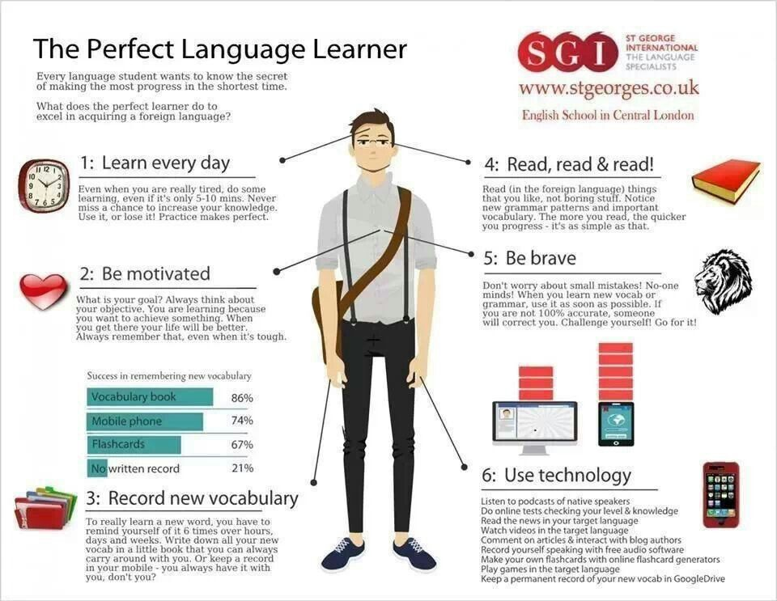

Student Name:___________________________________________ Period:_________
(Please Print)

Academic Integrity: Students are not allowed to use automated translation engines from the Internet or any other electronic devices for any assignment. Nor can they ask a tutor, friend, or family member to write their compositions. Should a student be suspected of cheating by having another party complete an assignment, he/she will be given a zero on the assignment. All other school policies relating to attendance, tardies, conduct, and cheating are also enforced in this class.

Responsibility Contract:
My parent/guardian and I have read the above syllabus and understand the policies, procedures, and my responsibilities for Spanish. I know how to contact Ms. Rolón and I understand the expectations that are required of me to complete this course.

______________________ ________________________
Signature of Student Signature of Parent/Guardian
****
Dear Parents and/or Guardians,
Please fill out the additional information below.

Phone number(s)/emails (how you are most easily reached). Best time to call:

________________________________________________________________________

How would you describe your student’s personality? What are his/her strengths?

In what activities does your student participate? What does he/she do with his/her time outside of class?

Are there any concerns you have about the syllabus or your student’s ability to be successful in this course?

What is your family’s experience with the Spanish language and culture?

In regards to your student’s access to the internet, please check all that apply:

____ has unlimited access to the Internet at home.

____ has limited access (restricted use, only one computer in the family, etc.) to the Internet at home.

____ has unlimited access to the Internet on his/her phone.

____ only has access to the Internet at school or at the library (and is able to use it before/after school).

____ does NOT have time to access the Internet at school or the library and does NOT have internet at home.

Please complete and return this page to Profe Rolón by Tuesday September 6th, 2016

