¡O qué feliz la familia es!

Objective:
Students will create a family tree showing at least three generations. (3.0 vocabulary)
Students will describe the likes of at least 10 family and verbs (2.1 –AR verbs y gustar).
Students will share their project with the class.

You may be creative with your “family” as you use drawings/images to depict your family.
Debe incluir:
20 frases en español.
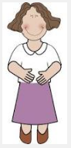
Photos/dibujos de la familia

- Preguntas para su consideración:

- Who are they?
- What is their relation to you?
- What do they do or like to do?
Juan es mi padre.
A él, le gusta caminar.
Carmen es mi madre.
A ella, le gusta trabajar.

‘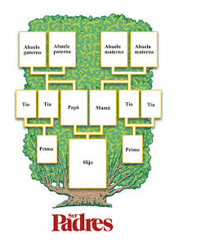
Rúbrica:

Todos los elementos incluidos _____/10

Gramática correcta ______/10

(All possessives should be in agreement and all –ar and gustar conjugations should be perfect)

Creatividad y visual _____/10

Pronunciación y fluidez _____/5

Total _____/35

Yo soy Gabriella.
Yo bailo, canto y estudio el español.
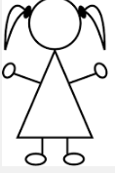

Rúbrica:
Todos los elementos incluidos _____/10
Gramática correcta ______/10
(todos los adjetivos deben (should) concordar (agree in gender and number) con la persona y estar en la posición correcta) mi primo guapo / mi guapa primo

Creatividad y visual _____/10

Pronunciación y fluidez _____/5

Total _____/35

